Command: whoami
Description: Displays the current user account.
Example: Running “whoami” in the terminal will show your username.

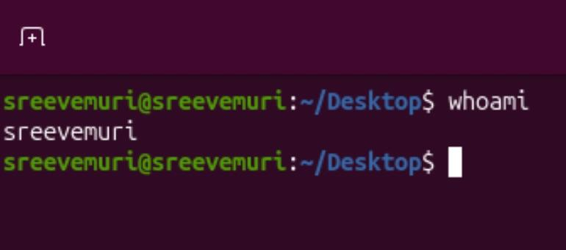

Command: ls
● Description: Lists files and directories in the current directory.
● Example: ls will display files and folders in your current directory, and ls -lprovides detailed information.

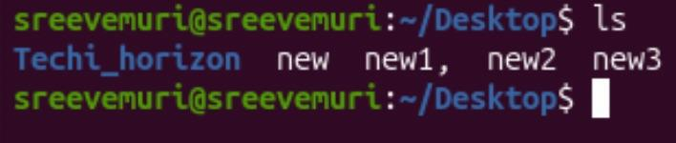

Command: ip a
● Description: Lists your IP address and network interfaces.
● Example: ip a show all network interfaces and their IP addresses.

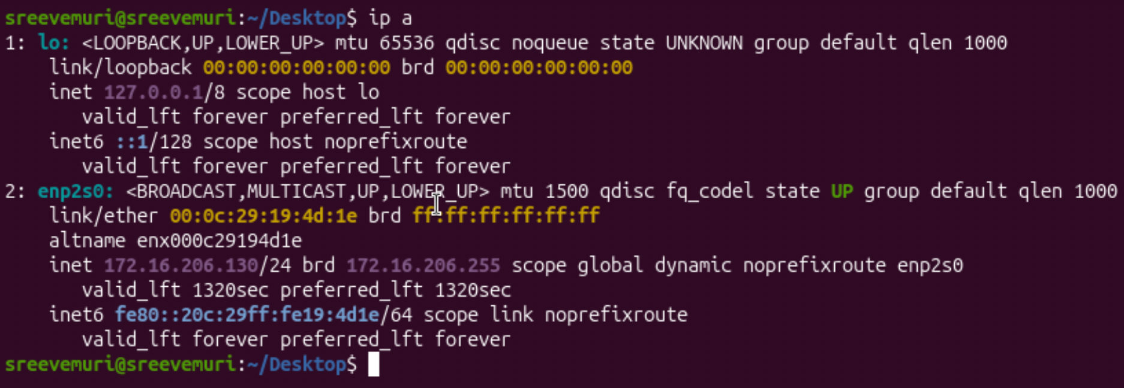

Command: cat
● Description: Reads the contents of text files.
● Example: cat myfile.txt will display the content of myfile.txt.
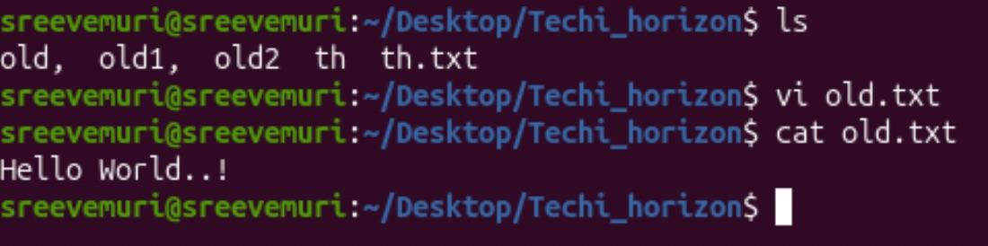

Command: passwd
● Description: Used to change the password of the user account.
● Example: Typing passwd and following the prompts will allow you to change your password.
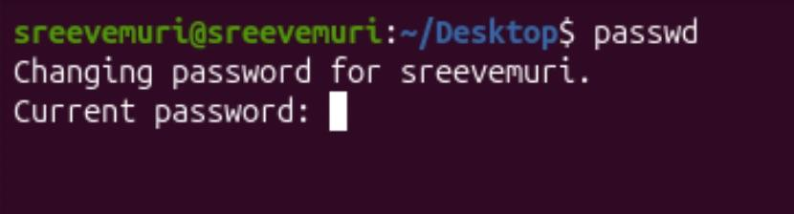

Command: touch
● Description: Creates empty files, mainly useful to test write ability.
● Example: touch newfile.txt creates an empty file named newfile.txt.
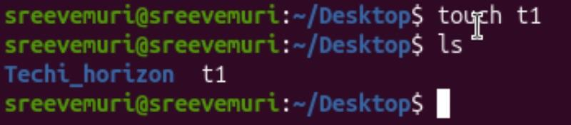
Command: pwd
● Description: Stands for Print Working Directory; shows which directory you are in.
● Example: Running pwd might return /home/john_doe.
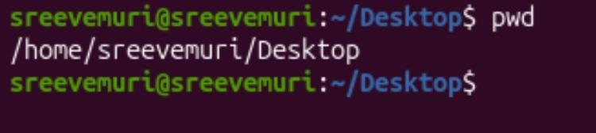

Command: man
● Description: Accesses the system documentation for commands.
● Example: man ls will show the manual for the ls command.
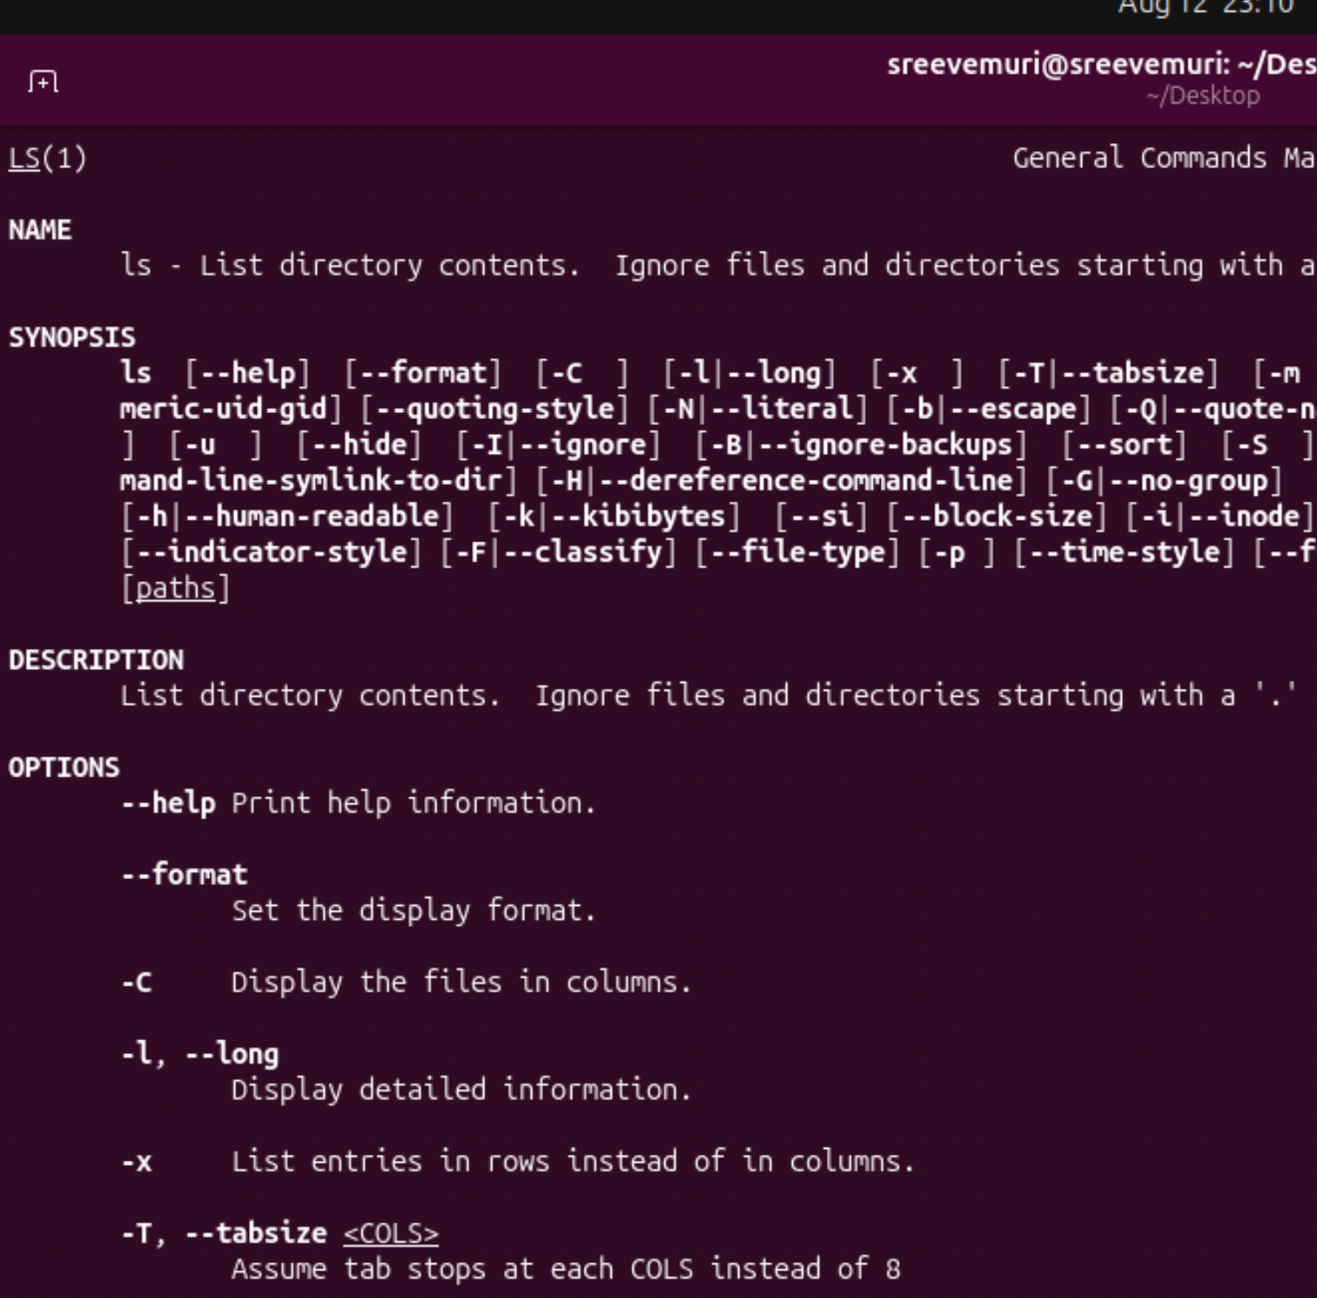

Essential File Management Tools Commands
Command: ls
● Example: ls /home/user/Documents
● Description: Lists files and directories within a specified path. This command is used to view the contents of directories.
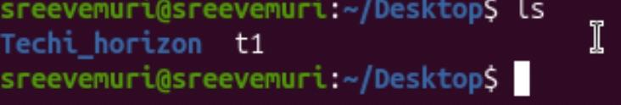
Command: cp
● Example: cp source.txt destination.txt
● Description: Copies files from one location to another. This command is used to make duplicates of files.
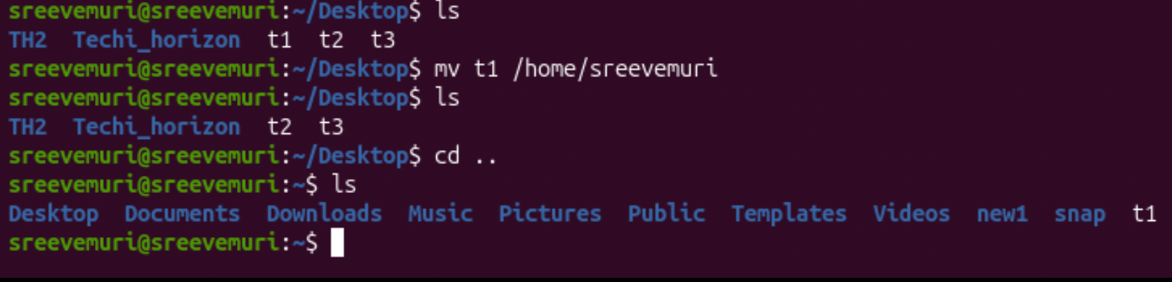
Command: mkdir
● Example: mkdir new_directory
● Description: Creates a new directory. This command is used when you need to make a new folder.

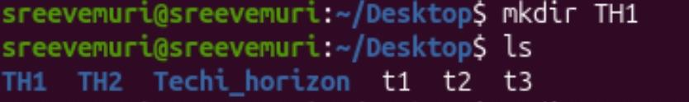

Command: rmdir
● Example: rmdir empty_directory
● Description: Removes a directory, but only if it's empty. This command is used for deleting empty folders.
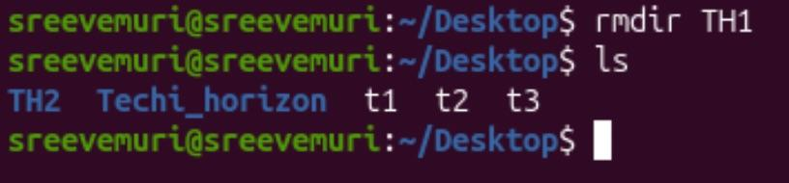

Command: mv
● Example: mv oldname.txt newname.txt
● Description: Moves or renames files and directories. This command can change the location or the name of a file.
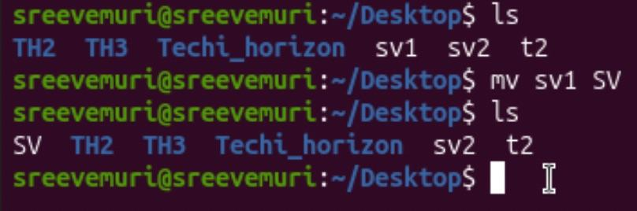

Command: rm
● Example: rm filename.txt
● Description: Removes files or directories. This command deletes files or directories.
● Note: When combined with options -r(recursive) and -f(force), as in rm -rf directory_name, it becomes a powerful command
that can delete directories and their contents without asking for confirmation
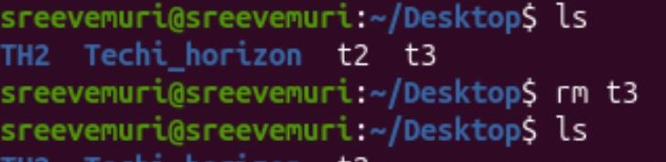

find: A utility to find files based on various properties.
● Example: find /home -name "*.txt"searches for text files in the /home directory.
● Description: Searches for files and directories in a given path
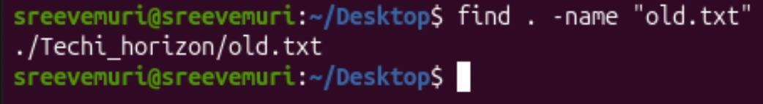

Locate: Used for quickly searching the database of system's contents.
● Example: locate filenamefinds the location of filename.
● Description: Fast file searching, requires running updated for an updated database.
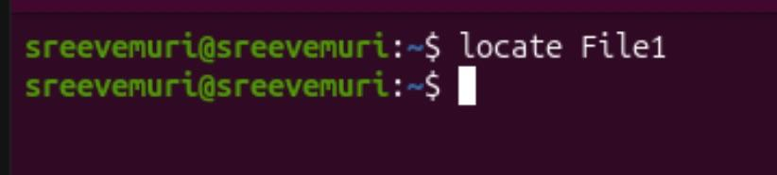
which: Finds the location of executables in the PATH.
● Example: which python shows the path of the Python executable.
● Description: Useful for finding executable files in system's PATH.
tar: Archives multiple files into a single file.
● Example: tar -cvf archive.tar /foldercreates an archive of a folder.
● Description: Combines multiple files into a tarball.
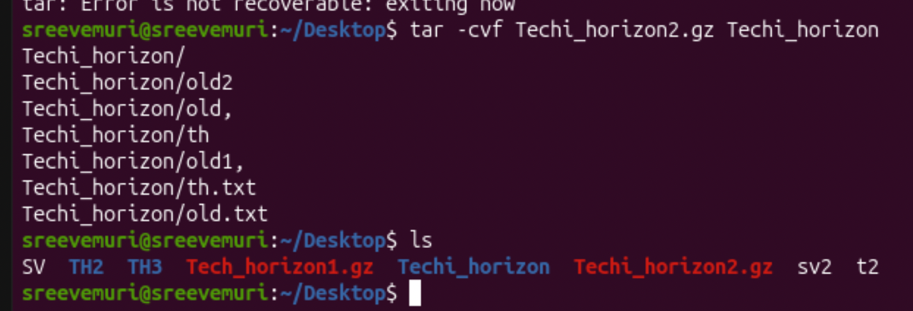
gzip: Compresses files.
● Example: gzip file.txtcompresses file.txt.
● Description: Reduces the size of files using compression.
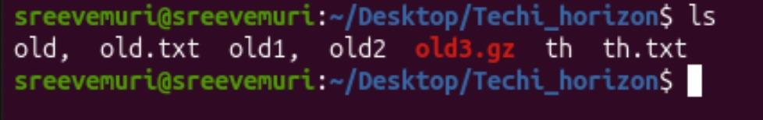
bzip2: A file compression utility.
● Example: bzip2 file.txtcompresses file.txt.
● Description: Offers better compression ratios than gzip at the cost of speed.
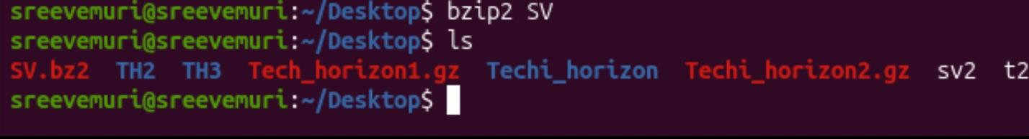

xz: High compression utility.
● Example: xz file.txtcompresses file.txt.
● Description: Provides the best compression ratio.
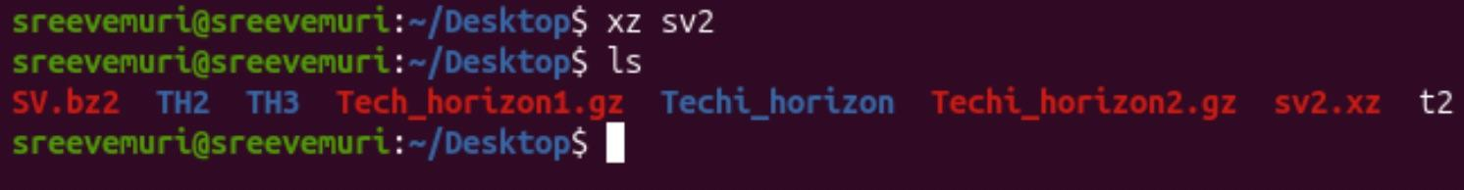
zip: Used for packaging and compressing (archiving) files.
● Example: zip archive.zip file1 file2creates an archive with file1and file2.
● Description: Commonly used for creating .zip files.
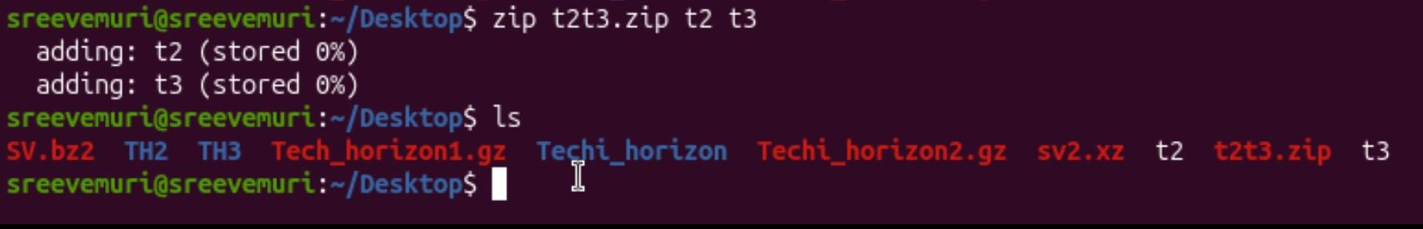
file: Determines the type of a file.
● Example: file image.jpgdisplays the type of image.jpg.
● Description: Useful for identifying file formats.
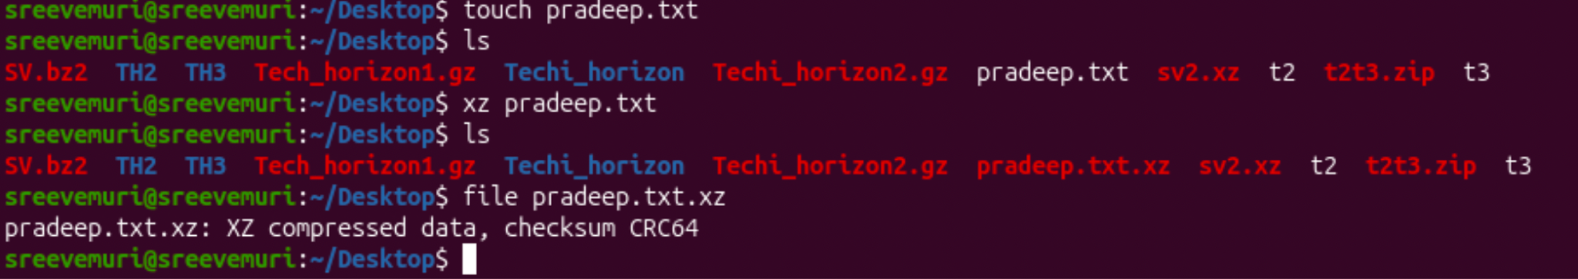
mount: Attaches a filesystem to a specified directory.
● Example: mount /dev/sdb1 /mntmounts the device sdb1to /mnt.
● Description: Used to access filesystems on different storage devices.
